

CCEN 302 Course Project
Audio Frequency Analysis

Student Names & ID#
Yazan Kassab – 10065547
Abdulrahman Junaid – 100066011
Jesher Jebson – 100065908
Khaled Maarouf – 100059293

Executive summary
This report outlines the methodology and results of an audio frequency analysis, audio processing, and audio quality evaluation project for the CCEN 302 signals and communication systems course.
The project deals with a short audio file that contains both speech and music, analyzing the audio file in time and frequency domain, as well as processing the audio by down sampling and re-quantization of the original audio signal, and then evaluating the quality of the audio file after processing it.

Methodological overview
The audio signal used for the project is an audio file that was recorded using a laptop with a sampling rate of 44.1 kHz and a bit depth of 16 bits. The audio recording is 20 seconds long and is composed of two parts: The first is human speech, while the second is a piece of music.
The recorded audio file is then processed using the MATLAB platform with the use of other modules, such as the signals processing toolbox provided by P. Furthermore, Simulink are built that mimic their equivalent MATLAB scripts and are then compared together to find any differences between MATLAB results and Simulink results.

Project tasks distribution
Team member | Task
Yazan Kassab | Audio Acquisition, Time and Frequency analysis of original audio signal
Abdulrahman Junaid | Downsampling and Aliasing
Khaled Maarouf | Bit-depth reduction (quantization)
Jesher Jebson | Objective quality metrics of processed audio signals

Task 1: Audio Acquisition and Analysis

MATLAB:
For the first task, the audio file must be recorded with a specified sampling rate and bit-depth. For our project, the sampling rate used is 44.1 kHz and a bit-depth of 16 bits. The audio signal was recorded using the laptop microphone with the Audacity program and saved as a .wav file.
The analysis of the audio signal begins by importing it to MATLAB. The audio file data can be loaded using the audioread function, which returns a vector of floating-point numbers and the sampling rate of the recorded audio, which in this case is 44.1 kHz. The code for loading is shown below:
[originalAudio, Fs] = audioread("../Audios/SpeechMusic.wav");
Next, the signal is plotted in the time domain using the plot command of MATLAB. The audio file’s amplitude vs time plot is shown below in Figure 1.
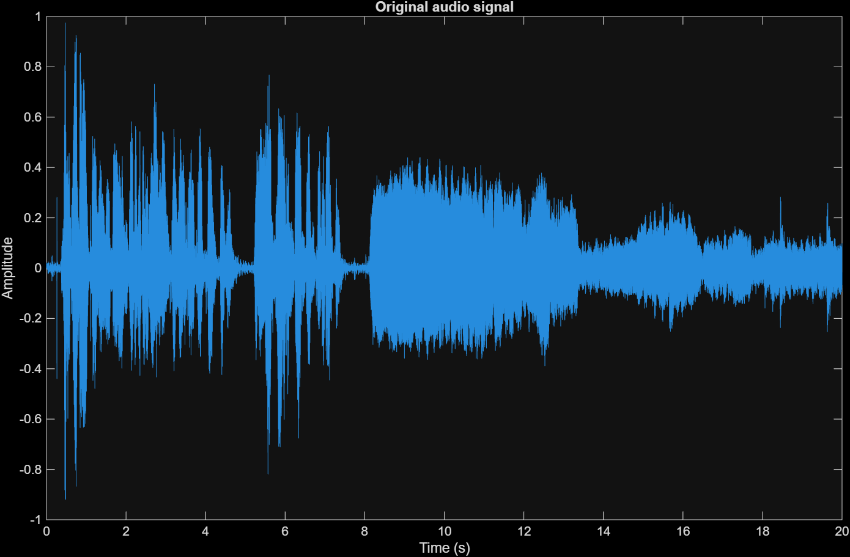
Figure 1: Original audio signal time plot
After plotting the audio signal in time, we can start with the frequency analysis of the audio signal. To find the frequency spectra of the audio signal, we can use the Discrete Time Fourier (DFT), which transforms a discrete signal in time into a discrete function in the frequency domain. The reason that we use the DFT to analyze the signal instead of the Discrete Time Fourier Transform (DTFT) is because the DTFT returns a continuous signal, which cannot be efficiently stored in a computer of limited storage. Furthermore, we can use a specialized algorithm of the DFT known as the Fast Fourier Transform (FFT), which can quickly compute the DFT of a signal, and since the sampling frequency of the signal is large enough, we can assume that the DFT output is virtually continuous.
To perform an FFT on the loaded time-domain audio signal, we can use the fft function in MATLAB, which takes in a vector of data, in our case the original audio signal, and returns its FFT. The length of the output of the FFT is equal to the number of samples in the original audio recording.
However, the FFT is symmetric, which means that the positive half of the frequency spectrum of the FFT is the complex conjugate of the negative half of the frequency spectrum. Since our data is a real signal (audio signals are real signals), then the positive and negative sides of the FFT have the same magnitude. Furthermore, the fft function in MATLAB scales the output by a factor equal to the length of the original time signal. As such, it is necessary to process the FFT output accordingly to generate a single-sided frequency spectra of the original signal. To do that, we need to take only the positive frequency part of the FFT, multiply it by 2 since it is symmetrical to the negative part and remove the DC component (index = 1) and the Nyquist frequency (Fs = 44.1kHz/2). The single-sided frequency spectra of the original audio is shown below in Figure 2.
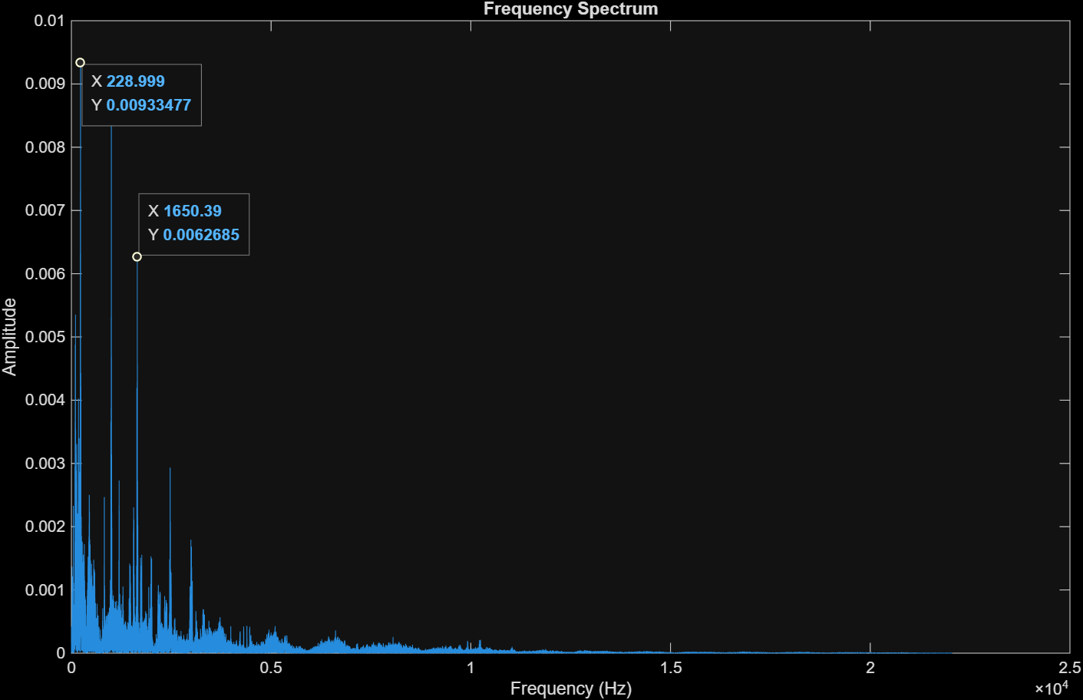
Figure 2: Frequency Spectrum of original audio recording
We can plot the frequency spectrum using the decibel scale instead of using amplitude. To do so, we can plot 20 * log₁₀(fftAmplitude). The plot of the frequency spectrum in decibels is shown below in Figure 3.
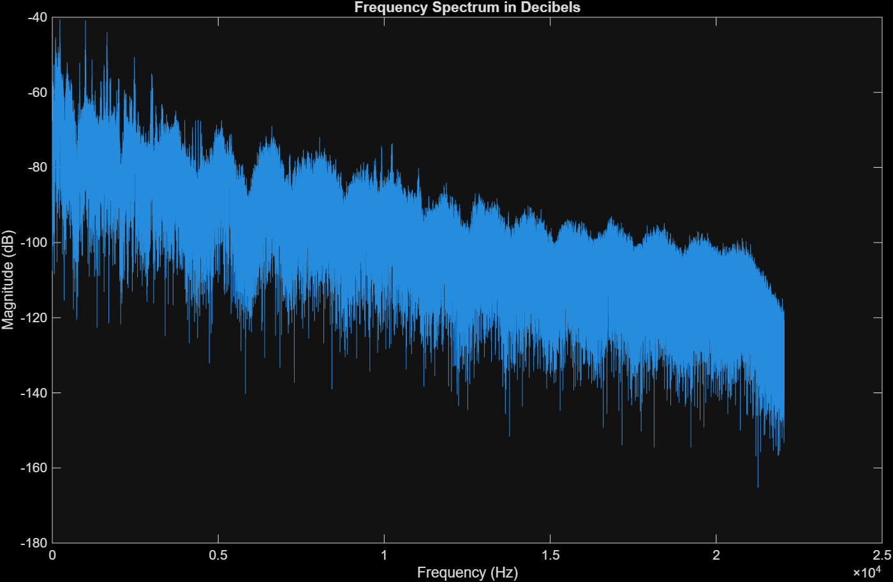
Figure 3: Frequency Spectrum of original audio in decibels

Finally, we can plot the spectrogram of the original audio signal. A spectrogram shows the amplitude of frequency across time, with the time plotted in the x-axis, frequency on the y-axis and amplitude shown as a color. The spectrogram of the original audio signal is shown below in Figure 4.
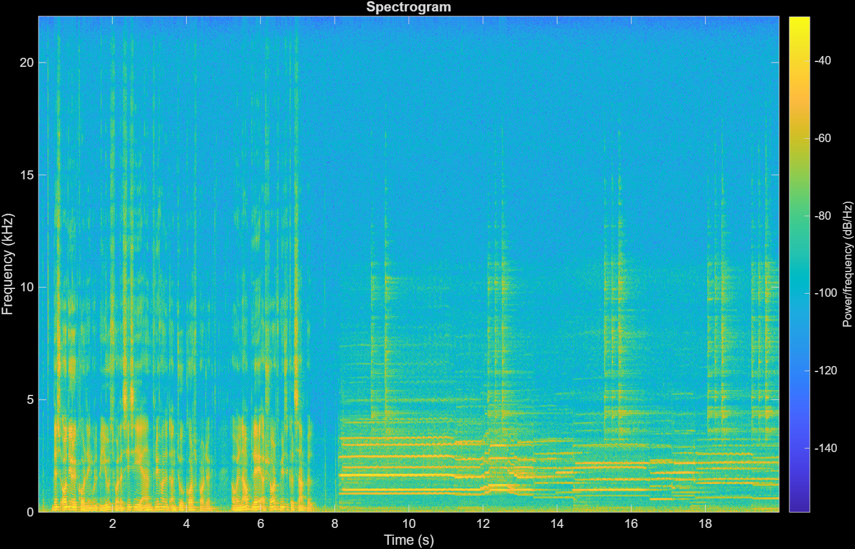
Figure 4: Spectrogram of original audio

Simulink:
Next, we will use Simulink to perform audio analysis in time and frequency. Simulink designs are block-based and as such it is much simpler than the MATLAB code. The Simulink design for the time and frequency analysis is shown below in Figure 5.
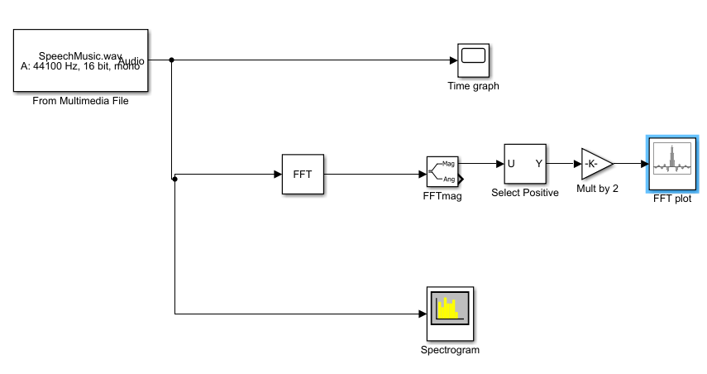
Figure 5: Simulink design for the second part
Like the MATLAB implementation, the audio file is first loaded using the “From Multimedia File” block which outputs the audio array as well as it’s sampling frequency. Next, we use the scope block to graph the audio signal in space, shown below in Figure 6.
Figure 6: Original audio signal time plot in Simulink
Next, we use the FFT block to produce a frequency spectrum of the audio signal. Next, we must process the audio signal to produce a single-sided frequency spectrum. First, we take only the magnitude of the FFT, next we take the positive frequencies of the FFT and multiply by 2, like what was done in the MATLAB code. Finally, the FFT data array is plotted using the array plot block, shown below in Figure 7.
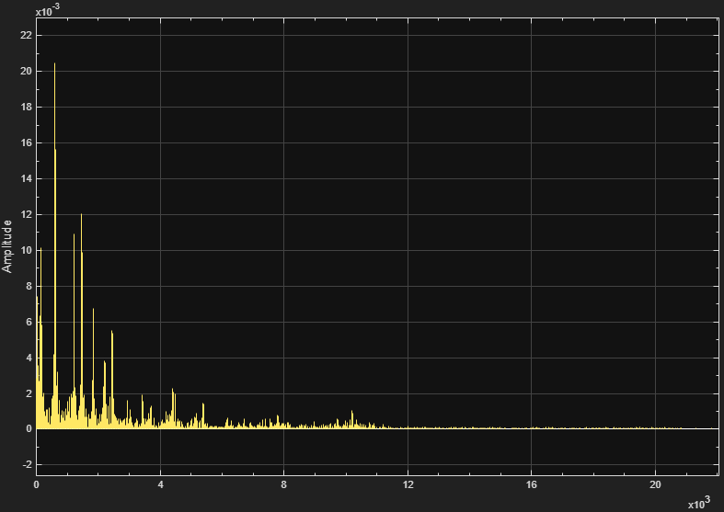
Figure 7: Single-sided FFT of original audio signal (Simulink)

Finally, we can plot the spectrogram of the audio signal using the spectrogram block provided in the signals processing toolbox. The spectrogram is shown below in Figure 8.
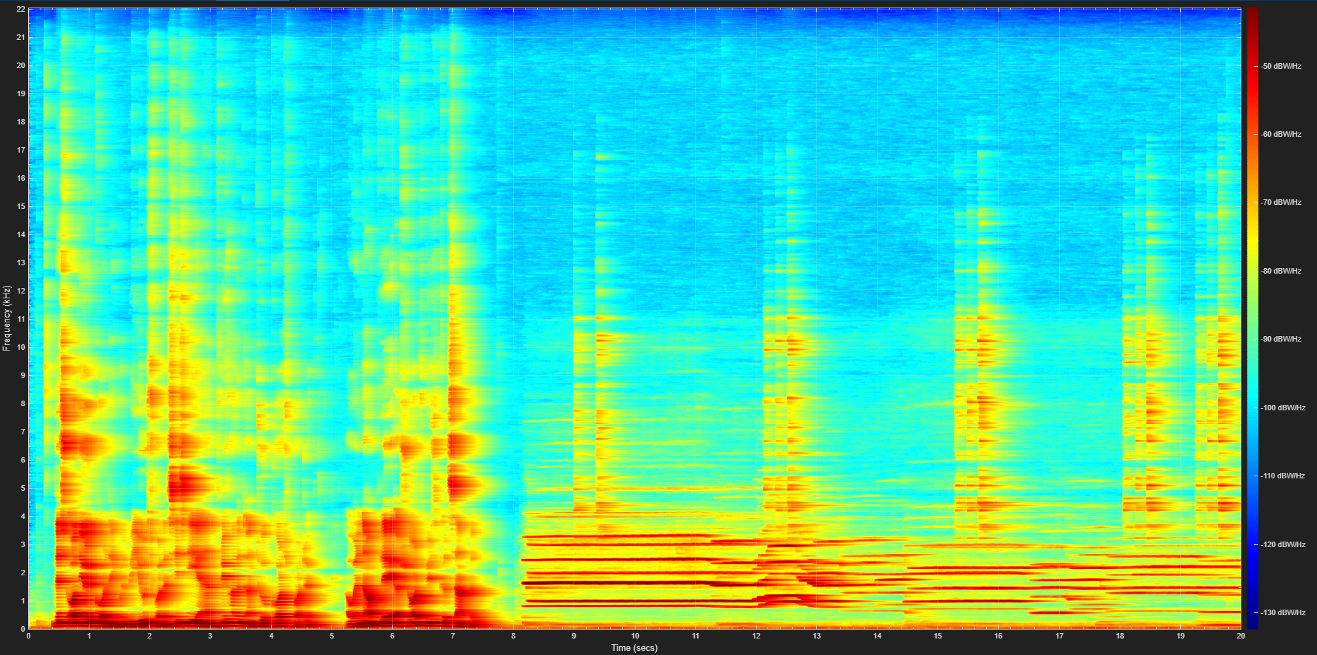
Figure 8: Spectrogram of original audio signal (Simulink)
Comparing the outputs between the MATLAB and Simulink implementation, we can see that their outputs are fairly similar, with some minor differences such as the color intensity of Simulink’s spectrogram compared to the MATLAB implementation, but they still show the same information.

Task 2: Downsampling and aliasing
Abdulrahman Junaid | CCEN 302 | 5 November 2026
The objective was to reduce the sampling rate of the same speech/music recording and compare conversion with and without an anti-aliasing (AA) low-pass filter. The original recording contains 882,005 mono samples at 44.1 kHz in a 16-bit PCM WAV file, approximately 20 seconds long. Acquisition and baseline analysis are described in Task 1.

Why aliasing occurs
Sampling rate is the number of measurements taken each second. The Nyquist limit is half that rate: fN = Fs/2. To avoid aliasing, the signal must be sufficiently band-limited below this limit. Otherwise, different continuous frequencies can produce the same samples, and high-frequency energy appears at a lower frequency. This false lower-frequency content is called aliasing.
An AA low-pass filter suppresses frequencies above the new usable band before samples are removed. Filtering after downsampling cannot separate an alias from genuine content at the same frequency. Practical filters have a transition band and finite attenuation, rather than a perfect cutoff.
Output rate (Hz) | Nyquist (Hz) | Ratio p/q | Samples/path
22050 | 11025 | 1/2 | 441003
11025 | 5512.5 | 1/4 | 220502
8000 | 4000 | 80/441 | 160001
4000 | 2000 | 40/441 | 80001

Controlled comparison
Every branch starts from the unchanged original recording. There is no independent amplitude normalization or reduced-bit quantizer in these sampling tests. The MAT files retain double-valued processing samples; the 16-bit label identifies the source/control, and exported WAVs use a 16-bit PCM container. Export rounding is separate from the sampling effect.
The evidence combines real-audio waveform, FFT and spectrogram comparisons with an existing known-frequency tone. The tone makes frequency folding identifiable; the real recording demonstrates the effect on a complex signal.

2.1 MATLAB methods and analysis

Integer and non-integer conversion
yNoFilter = x(1:2:end); % 22.05 kHz
yNoFilter11025 = x(1:4:end); % 11.025 kHz
Starting at index 1 keeps the first sample at t = 0. These branches retain every second or fourth sample without a dedicated AA filter. They are played and plotted using their actual lower sampling rates; changing only a rate label would change playback speed.
[p, q] = rat(FsOutput / Fs);
yNoFilterRate = interp1(originalTime, x, outputTime, "linear");
For 8 and 4 kHz, the ratios are 80/441 and 40/441. A constant integer indexing step cannot produce those exact rates. The code estimates samples at uniform target times by linear interpolation between adjacent source samples. Linear interpolation has a frequency response of its own; it is not an ideal transparent operation. Differences from the filtered path therefore include interpolation effects as well as AA filtering.
[yFilteredRate, coefficientsRate] = resample(x, p, q, 10, 5);
The filtered branch uses a Kaiser-window FIR design with n = 10 and beta = 5. MATLAB resample compensates its filter delay. The filters have 41, 81, 8,821 and 8,821 taps at the four respective rates. For rational conversion, the coefficients apply at the intermediate rate p times the input rate; polyphase processing avoids explicitly constructing a large zero-inserted signal.

Fair plots and time alignment
Waveforms use actual sample times and common amplitude limits. FFT magnitudes are divided by sample count; positive-frequency pairs are doubled, except DC and an exact Nyquist bin. Amplitude dB means 20 log10(A/1). A display floor of 1e-12 avoids log10(0), without modifying audio samples.
Spectrograms use approximately 30 ms Hamming windows, 20 ms overlap and 2,048 FFT points at every rate. Color limits are shared: -130 to -30 dB relative to 1 sample-unit squared/Hz. A kHz horizontal or vertical frequency label does not change PSD units from per Hz to per kHz. Zero-padding increases plotted grid density, not true frequency resolution.
For later quality evaluation, resampling back to 44.1 kHz restores a common time grid, not lost information. The full original sample interval is retained, without optimized time shifts or error-based edge trimming. Boundary effects remain in the comparison.

2.2 Real-audio frequency comparisons
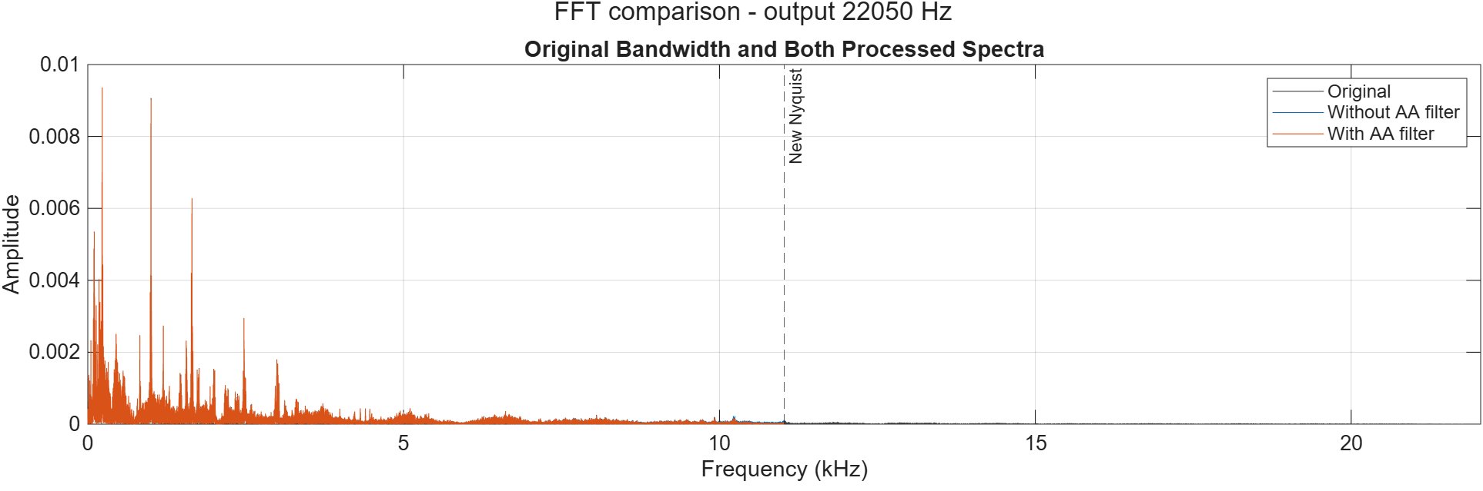
Figure 2.1. 22,050 Hz output: original and both processing paths; dashed line marks the new Nyquist limit. Amplitude scale is linear.
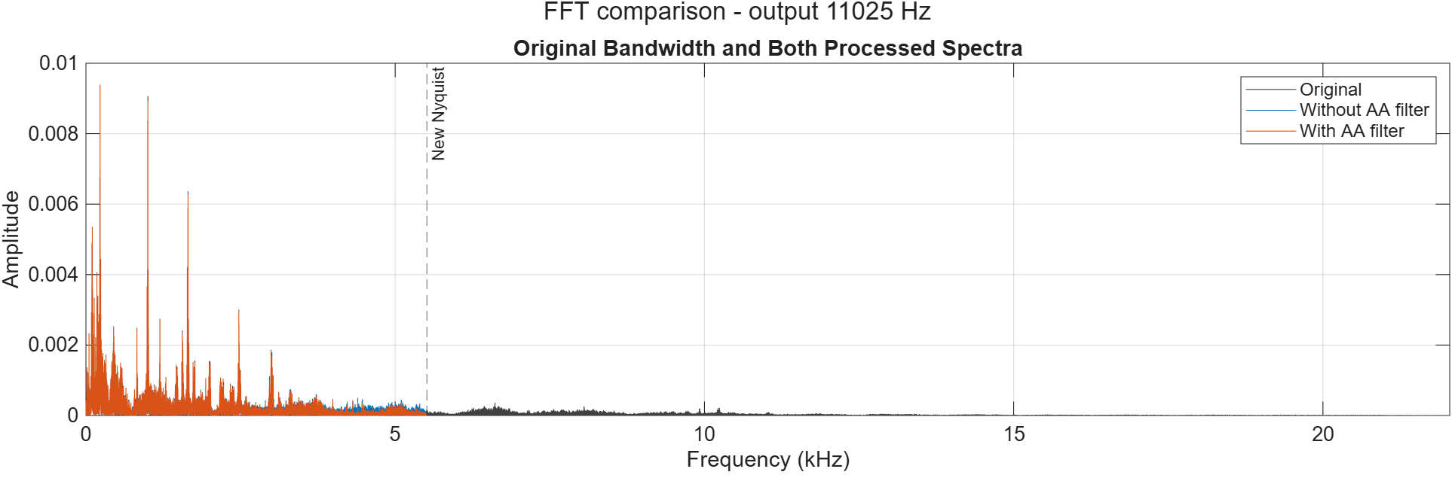
Figure 2.2. 11,025 Hz output: original and both processing paths; dashed line marks the new Nyquist limit. Amplitude scale is linear.
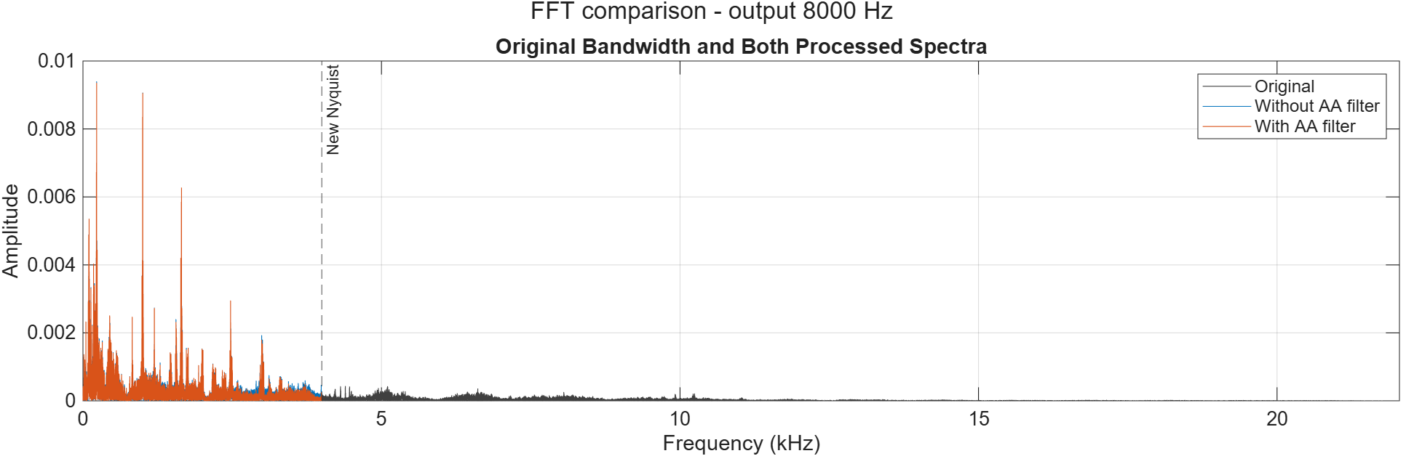
Figure 2.3. 8,000 Hz output: original and both processing paths; dashed line marks the new Nyquist limit. Amplitude scale is linear.
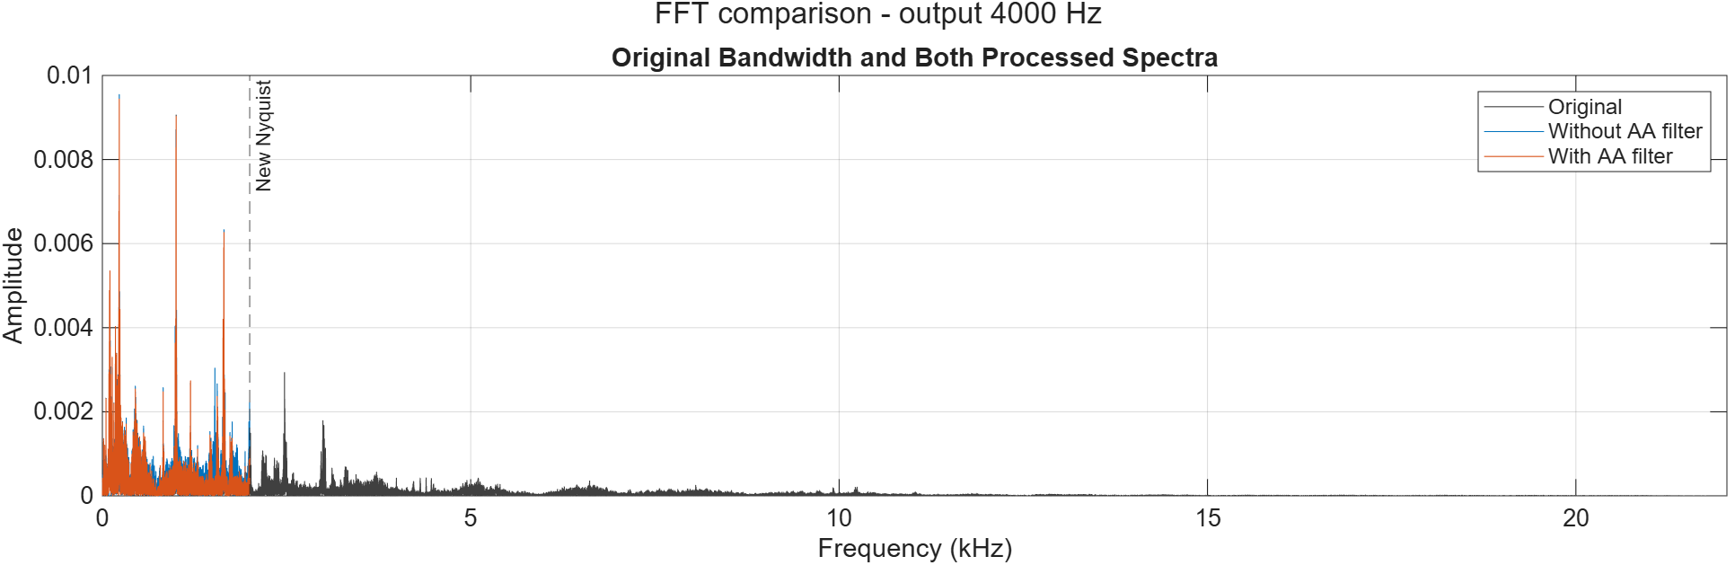
Figure 2.4. 4,000 Hz output: original and both processing paths; dashed line marks the new Nyquist limit. Amplitude scale is linear.
The largest original components lie at low frequencies, so the strongest peaks often overlap after filtering. This does not mean filtering is unnecessary: weaker high-frequency content can still fold into the retained band. At 4 kHz, only the band below 2 kHz remains available, making bandwidth loss and method differences more consequential.
These full-band views locate the removed bandwidth. Full-resolution shared-band dB views are supplied in the results folder for inspecting smaller differences. Individual peaks in speech/music cannot reliably be assigned an alias origin without a known-frequency reference.

2.3 Reading the time-frequency evidence
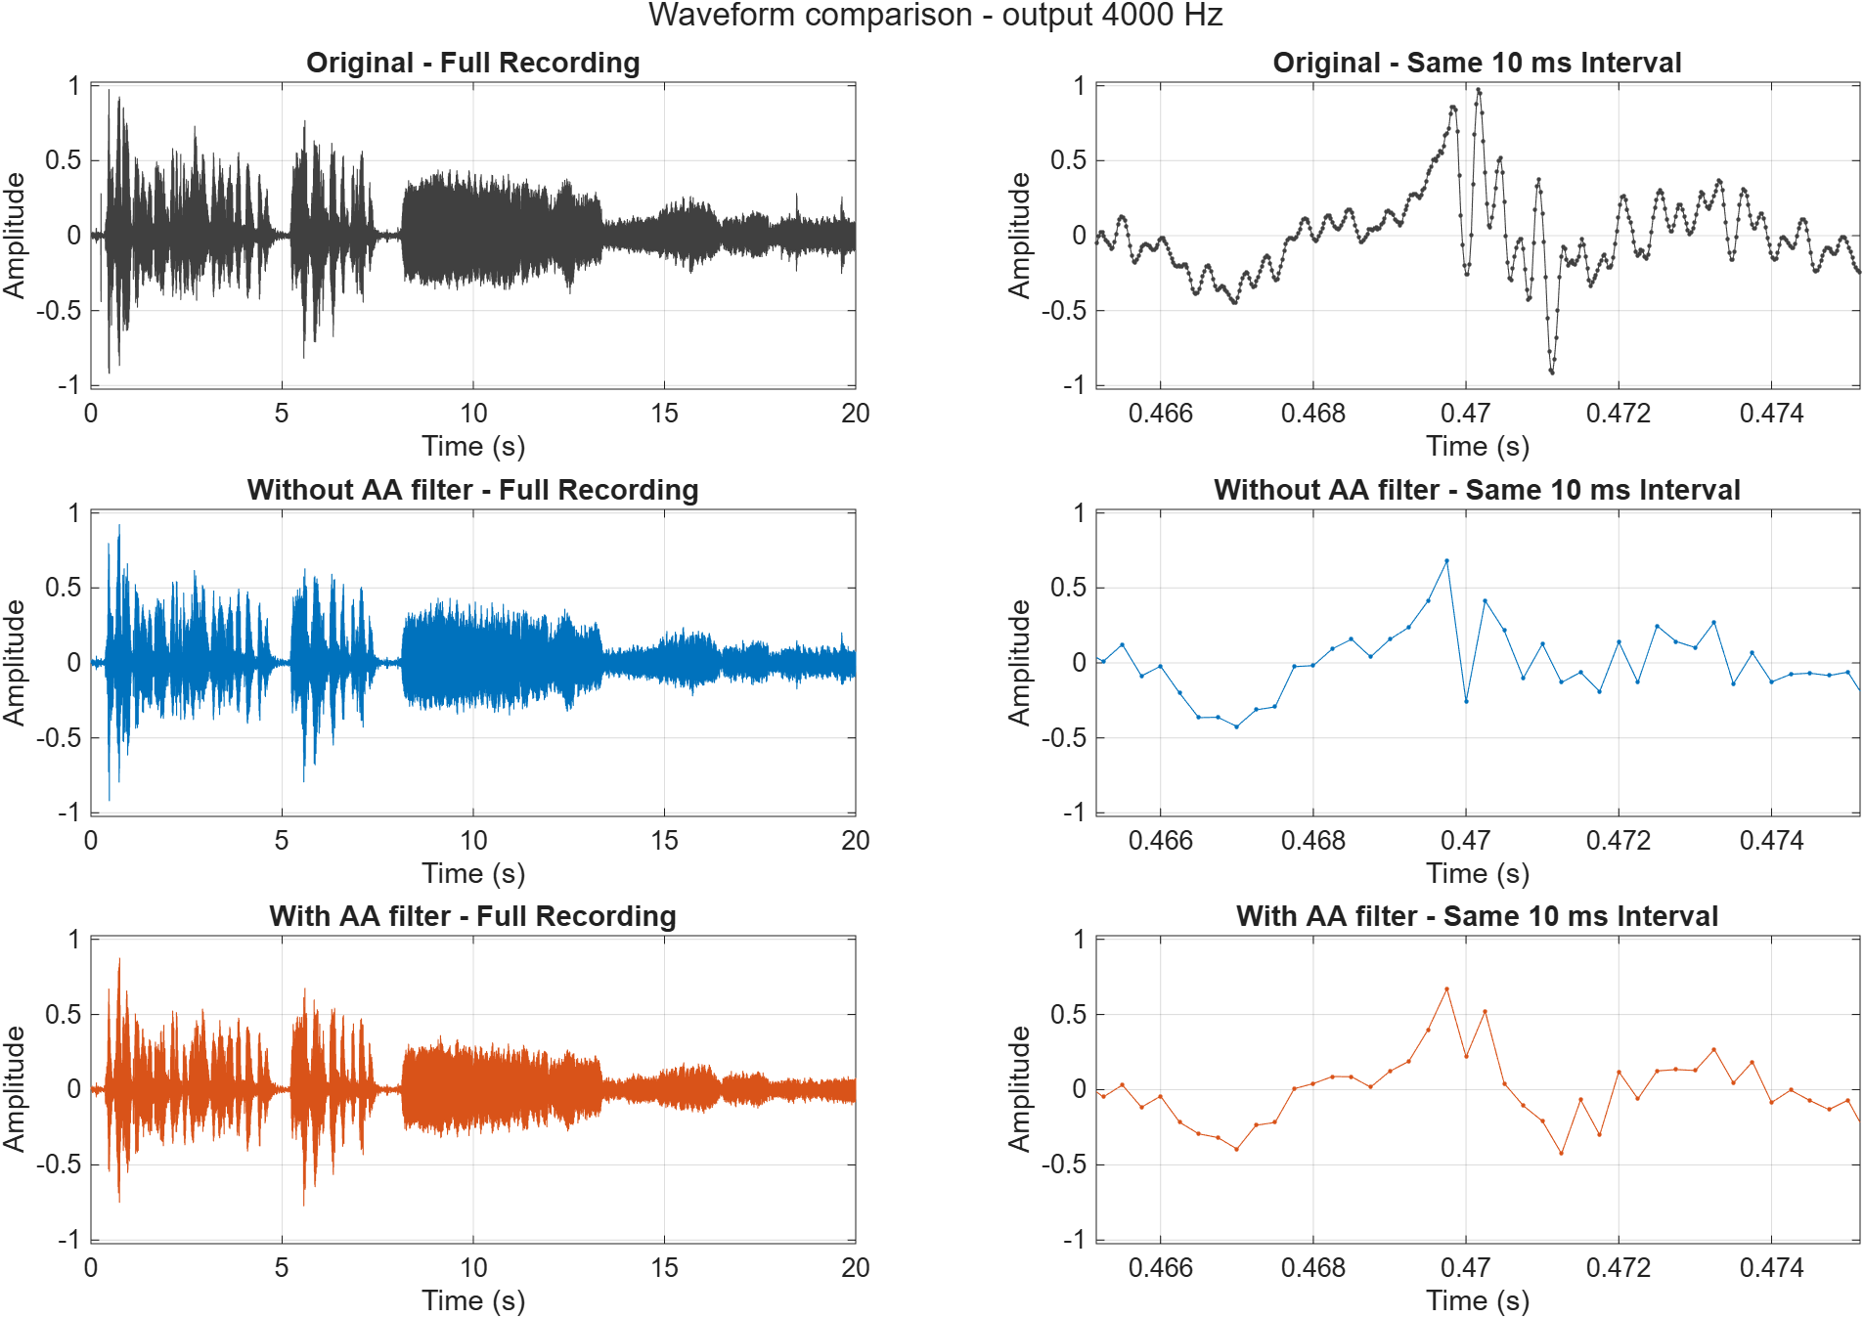
Figure 2.5. At 4 kHz, the full waveform preserves the broad time envelope while the common short-time zoom reveals local differences.
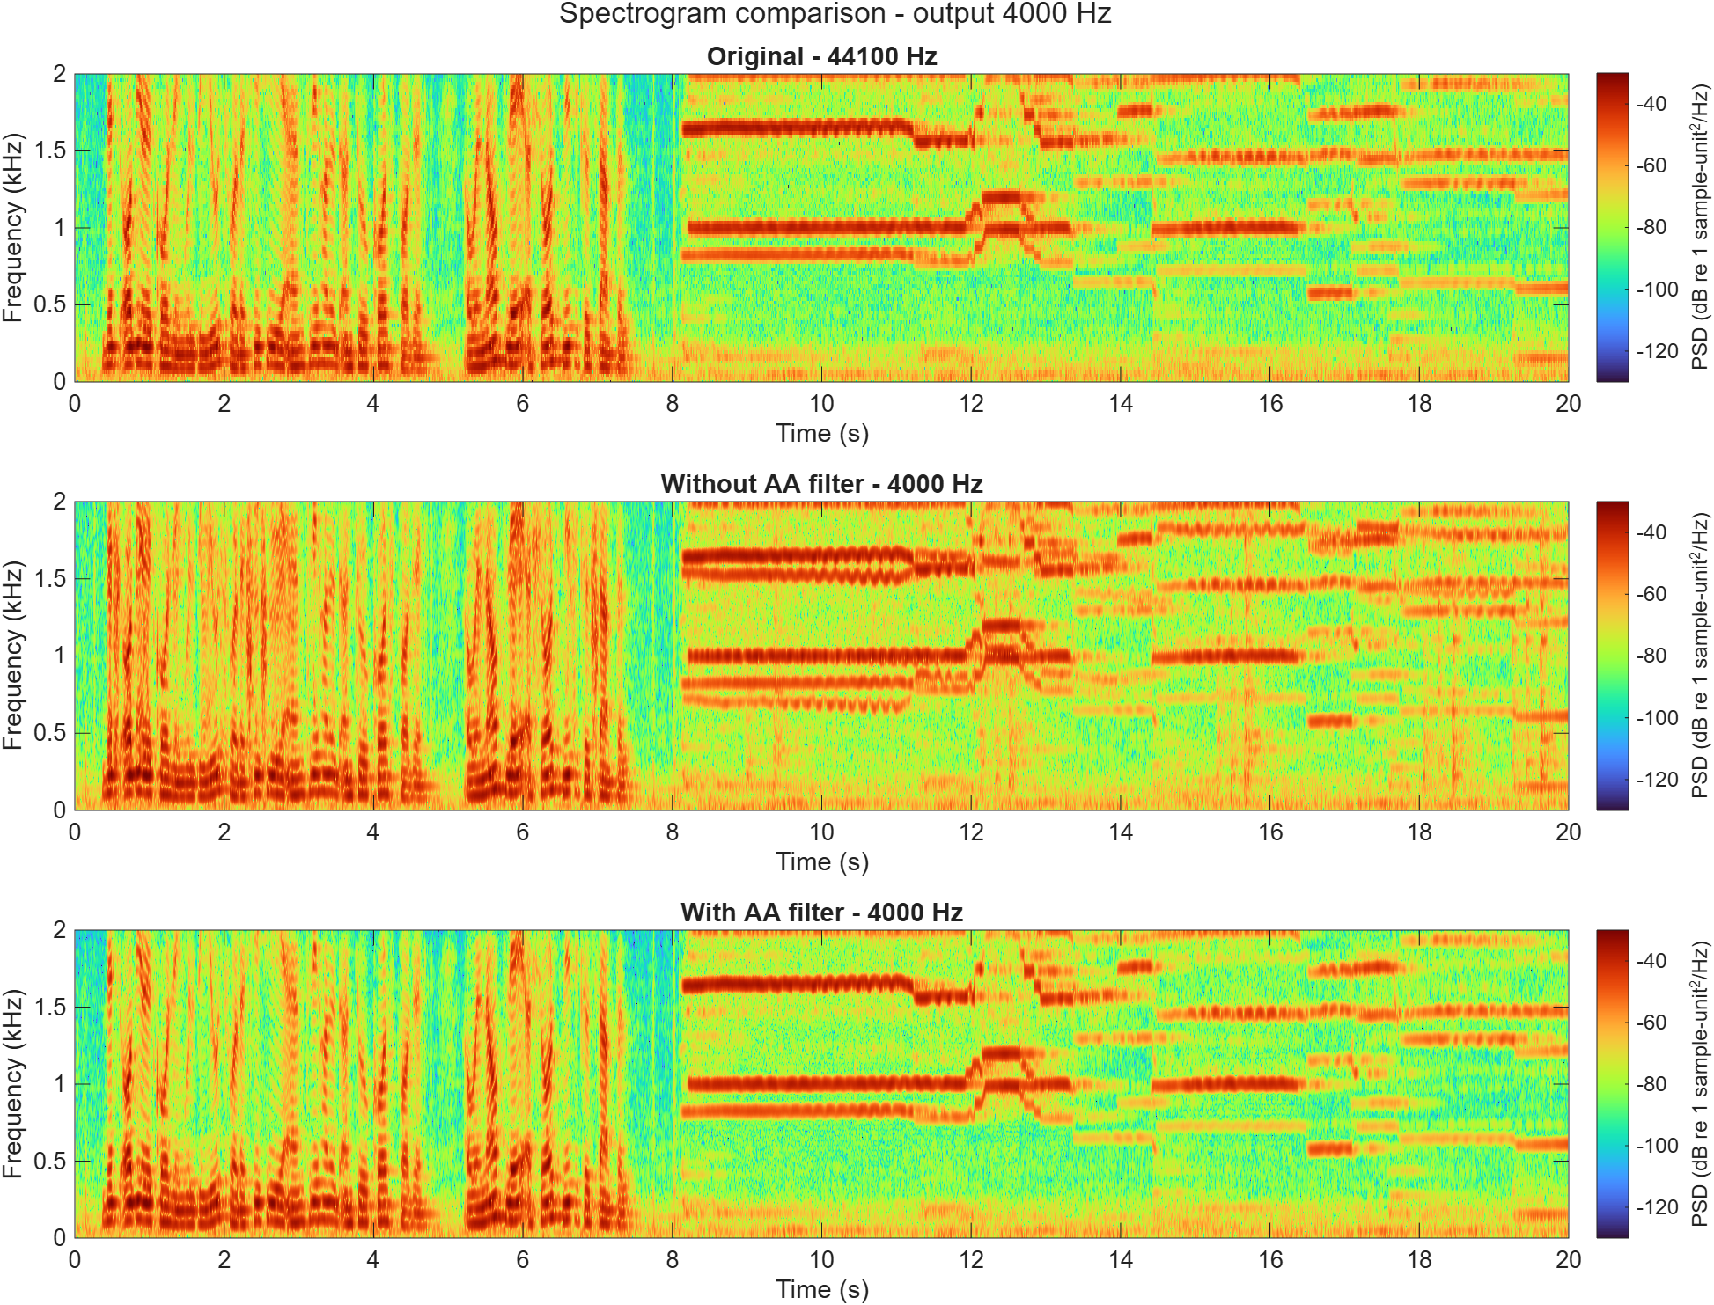
Figure 2.6. Original, unfiltered and filtered signals shown over the same 0-2 kHz band with common PSD color limits.
The envelope describes when the recording is loud or quiet; it does not establish that fine detail is preserved. Horizontal spectrogram bands represent sustained components, while short vertical changes indicate time-local activity. Shared axes and color limits prevent a rescaled display from hiding processing differences.
Above-band original content is visible in Figure 2.4, not in this deliberately shared-band spectrogram. The 4 kHz output cannot retain that original high-frequency information faithfully. Appendix A supplies corresponding waveform and spectrogram views for the other three rates.

2.4 A directly identifiable alias
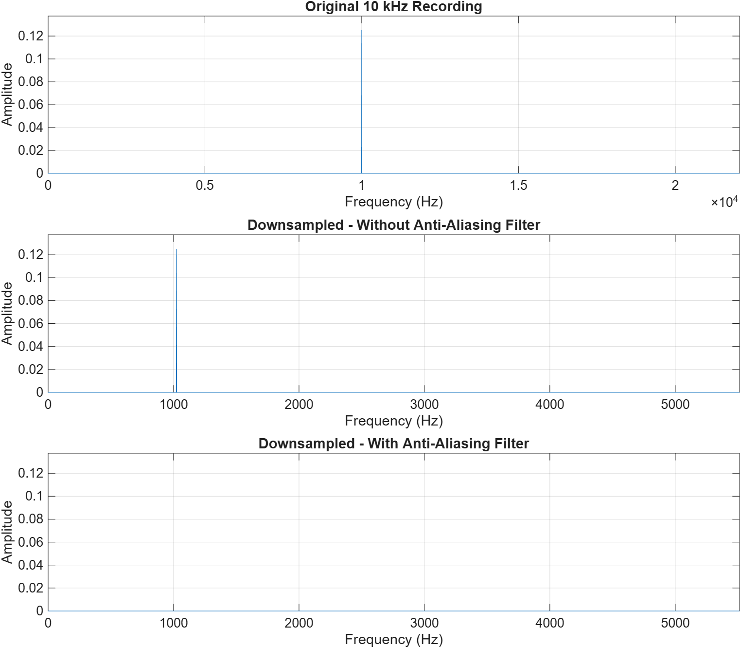
Figure 2.7. Existing 10 kHz sine: original, unfiltered reduction to 11.025 kHz, and filtered reduction on comparable amplitude scales.
The new Nyquist limit is 5,512.5 Hz, so the 10 kHz tone lies above it. Sampling at 11,025 Hz makes it indistinguishable from a 1,025 Hz tone:
Predicted alias = |10,000 - 11,025| = 1,025 Hz.
Path | Measured peak (Hz) | Peak amplitude
original | 10000 | 0.12497299
none | 1025 | 0.12497299
lpf | 1025 | 4.5683239e-05

The unfiltered peak agrees with the prediction and retains approximately the original amplitude. With filtering, the largest measured residual is much smaller. The suppression is 20 log10(Aunfiltered/Afiltered) = 68.74 dB. This is measured residual suppression for this tone, not a general SNR improvement or a claim of perfect rejection.
The known tone establishes frequency folding unambiguously. Together with the real recording, it supports both the theoretical explanation and the practical comparison required by the project.

2.5 Simulink implementation and agreement

Equivalent sampling branches
44.1 kHz source -> Downsample (2 or 4) -> unfiltered log
-> FIR Decimation -> filtered log
44.1 kHz source -> Linear interpolation -> unfiltered log
-> FIR Rate Conversion -> filtered log
L/M = 80/441 or 40/441
The integer models use the same selection offset and FIR coefficients as MATLAB. The 8/4 kHz models use 4,410-sample input frames: interpolation produces 800/400 samples, and FIR Rate Conversion uses the matching rational ratio. These saved models were run in R2026a for 20 seconds.
Logged frames were flattened into sample columns. The known FIR delay of 10 output samples was removed from each filtered branch, and surplus final-frame samples were discarded to match the exact reference interval. This corrects implementation timing; it does not optimize the result to conceal signal degradation.
Rate (Hz) | Filter | Delay removed | Max abs difference
22050 | none | 0 | 0
22050 | lpf | 10 | 3.33e-16
11025 | none | 0 | 0
11025 | lpf | 10 | 5.55e-16
8000 | none | 0 | 1.68e-11
8000 | lpf | 10 | 7.77e-16
4000 | none | 0 | 1.32e-11
4000 | lpf | 10 | 6.66e-16

All eight cases pass: tolerance 1e-10 without filtering and 1e-12 with filtering. At 8/4 kHz, frame-relative and whole-record interpolation use slightly different floating-point arithmetic. Filtered differences are at rounding scale. These results establish MATLAB/Simulink agreement; they are not NMSE or SNR against the original recording.
The source-connected FFT/spectrogram displays show the original signal, not the logged processed branches. Frame FFTs also differ from a full-record FFT. With 4,410-sample frames, the final frame contains only five real samples followed by padding, so its small broad spectrum is not representative of the whole recording.
% From repository root, reproduce the saved-model comparison:
addpath("Matlab")
Compare_All_Sampling

2.6 Discussion and conclusion

What the experiment establishes
Reducing the rate lowers the maximum usable bandwidth. Anti-aliasing filtering deliberately removes above-band content before conversion so it does not reappear as false lower-frequency content. The 10 kHz test provides the clearest evidence: the predicted and measured alias are both 1,025 Hz, and filtering strongly suppresses the residual.
The real-audio comparisons show why a waveform alone is insufficient. A similar overall envelope can coexist with lost bandwidth and changed spectral detail. At higher output rates, filtered and unfiltered curves can nearly overlap because the recording has relatively little energy in the affected band. At 4 kHz, preserving only frequencies below 2 kHz imposes a stronger limitation.

Limitations and handoff
The unfiltered rational-rate branches use linear interpolation, so their differences cannot be attributed exclusively to filtering. FIR filters also have finite transition bands and attenuation. Reconstructing to the original rate supports a valid time-grid comparison but cannot reverse aliasing or restore removed frequencies. No independent normalization was used.
The sampling handoff contains eight MATLAB controls and eight aligned Simulink controls with actual rates and timing metadata. Reduced-bit quantization, total NMSE/SNR, storage and case-specific listening interpretations are reported in the corresponding team sections. Abdulrahman reports that listening checks were completed; no unsupplied subjective observations are asserted here.

Conclusion
All four requested lower rates were implemented with both filter modes, and all eight platform comparisons passed their declared tolerances. The known-tone result confirms frequency folding predicted by sampling theory, with 68.74 dB measured suppression of the largest residual after filtering. The evidence demonstrates the need to filter before reduction while preserving the distinction between bandwidth loss, aliasing and numerical implementation error.

References and reproducibility
[1] CCEN 302 Project-3.pdf, sampling/aliasing requirements and grading criteria. [2] Project source: Sampling_Abdulrahman.m, Sampling_OtherRates.m, Aliasing_Demo.m and Compare_All_Sampling.m. [3] Saved evidence: case_manifest.csv, aliasing_summary.csv, alignment_checks.csv and simulink_comparison.csv in Results/Abdulrahman/Sampling. Measurements were produced in MATLAB/Simulink R2026a; this report revision reuses those results.
[4] MathWorks documentation: resample (mathworks.com/help/signal/ref/resample.html), interp1 (mathworks.com/help/matlab/ref/interp1.html), fft (mathworks.com/help/matlab/ref/fft.html), and spectrogram (mathworks.com/help/signal/ref/spectrogram.html).

Appendix A: 22,050 Hz comparisons
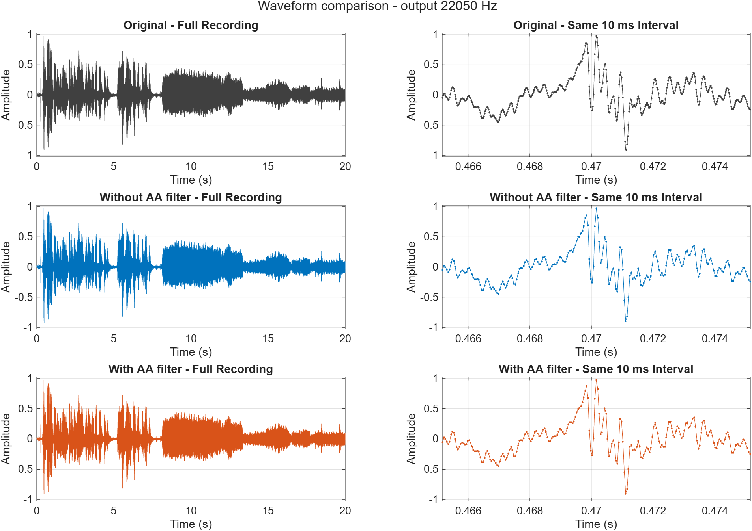
Figure A22050-1. Full waveform and common short-time zoom. Original and both processing paths use matching amplitude/time conventions.
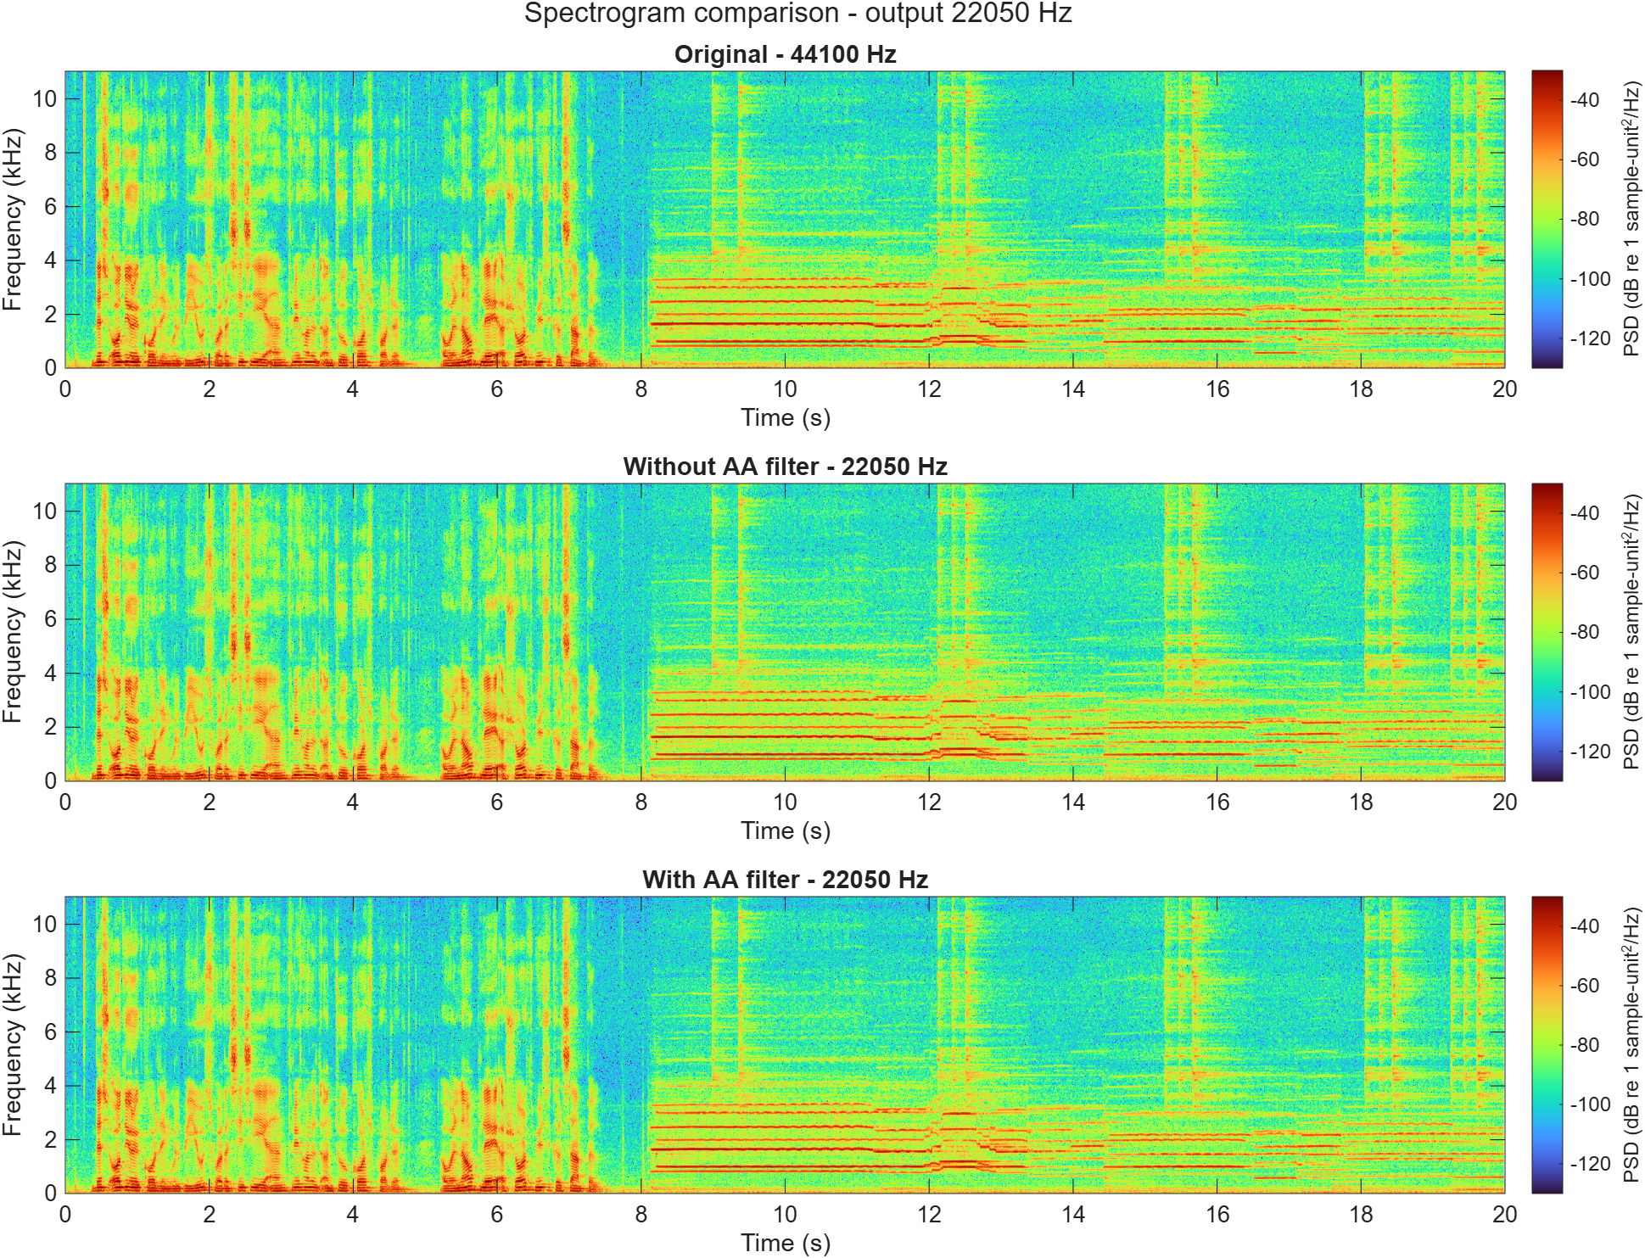
Figure A22050-2. Original, unfiltered and filtered PSD on the shared 0-11.025 kHz band, with the settings stated in Section 2.1.
These supporting plots complete the time-domain and time-frequency evidence across all four requested output rates. Full-resolution FFT plots, including shared-band dB views, remain in the reproducible results folder.

Appendix A: 11,025 Hz comparisons
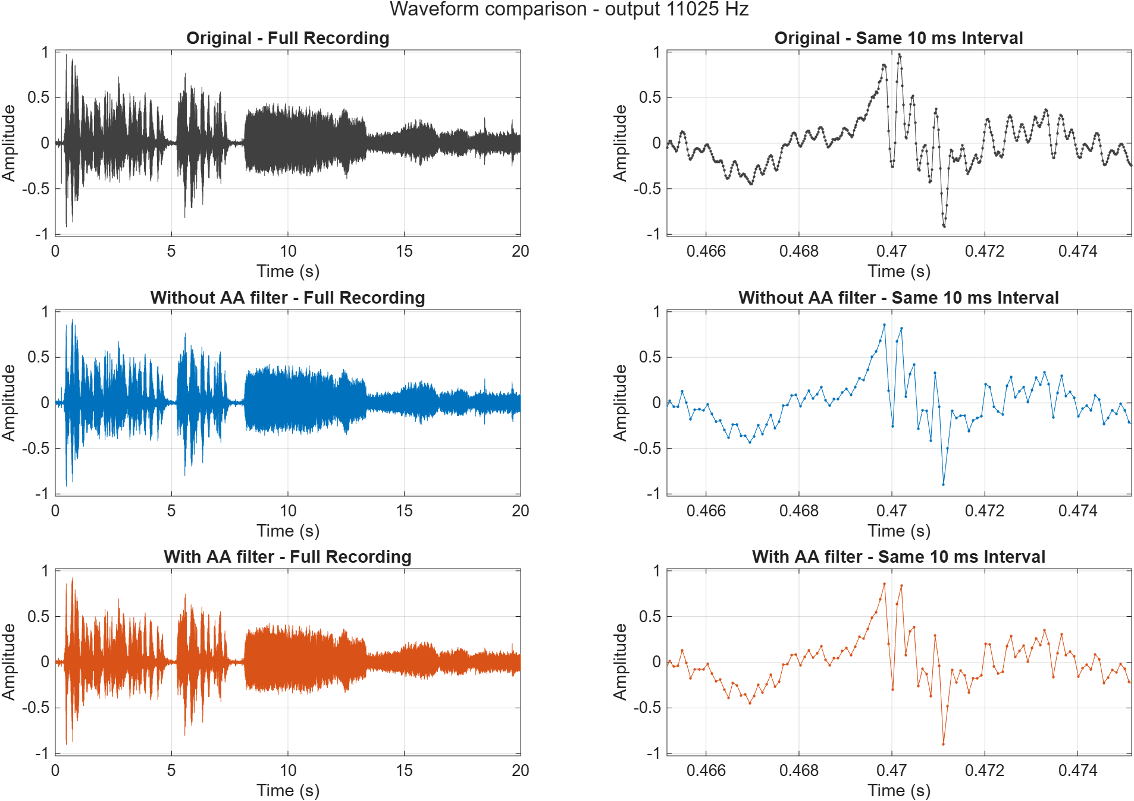
Figure A11025-1. Full waveform and common short-time zoom. Original and both processing paths use matching amplitude/time conventions.
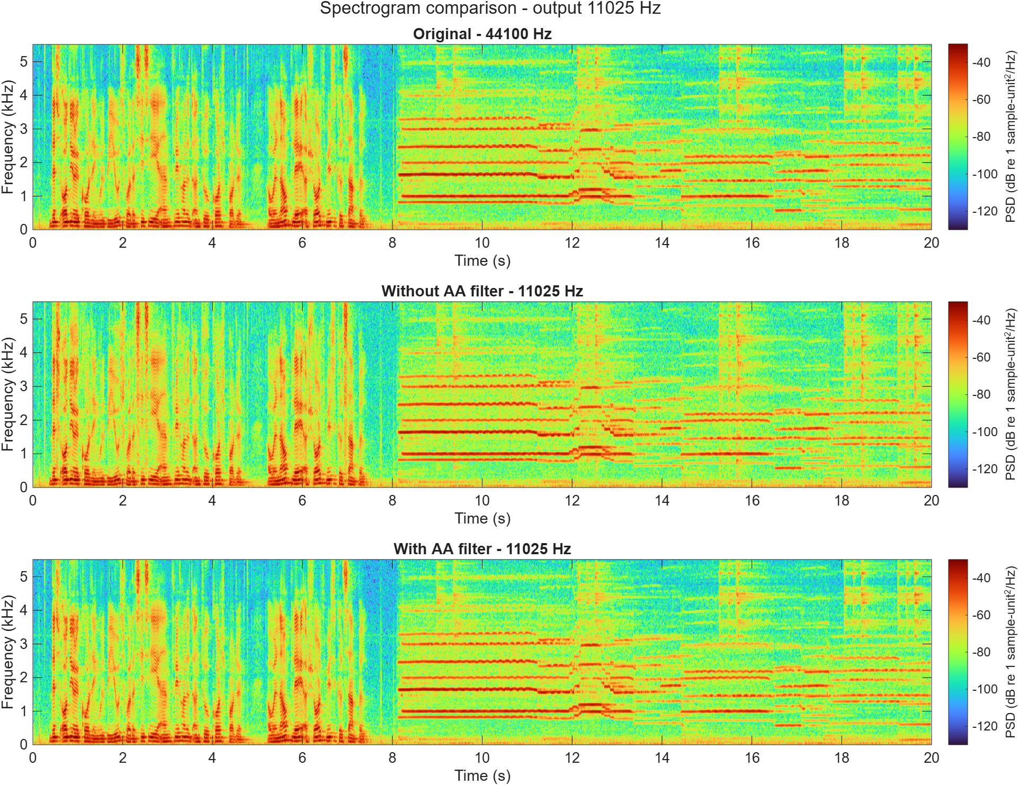
Figure A11025-2. Original, unfiltered and filtered PSD on the shared 0-5.5125 kHz band, with the settings stated in Section 2.1.
These supporting plots complete the time-domain and time-frequency evidence across all four requested output rates. Full-resolution FFT plots, including shared-band dB views, remain in the reproducible results folder.

Appendix A: 8,000 Hz comparisons
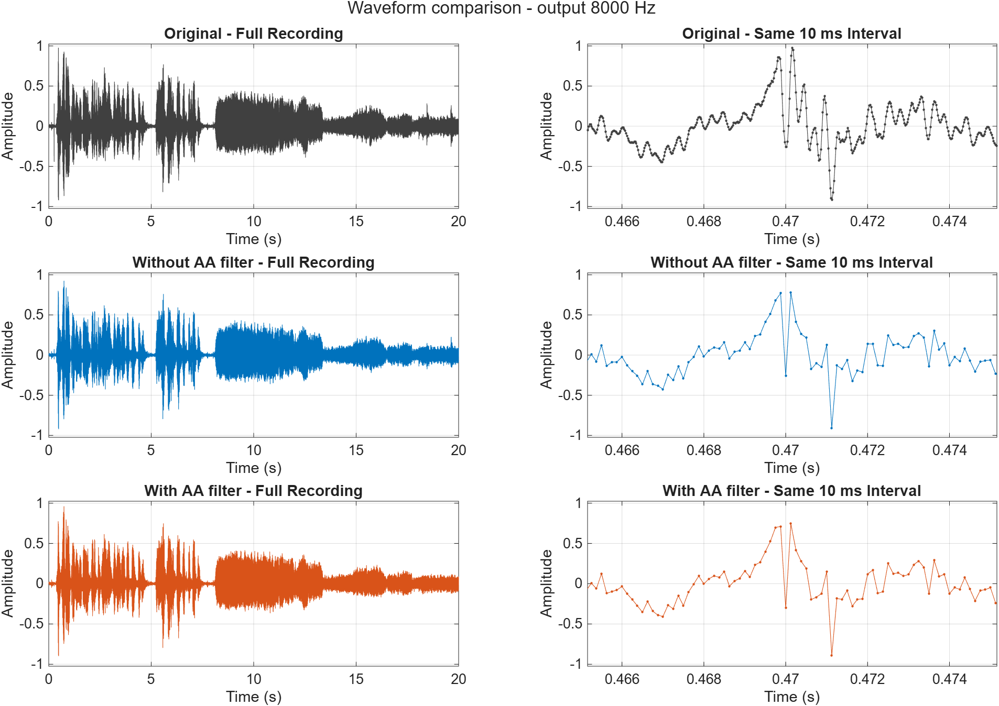
Figure A8000-1. Full waveform and common short-time zoom. Original and both processing paths use matching amplitude/time conventions.
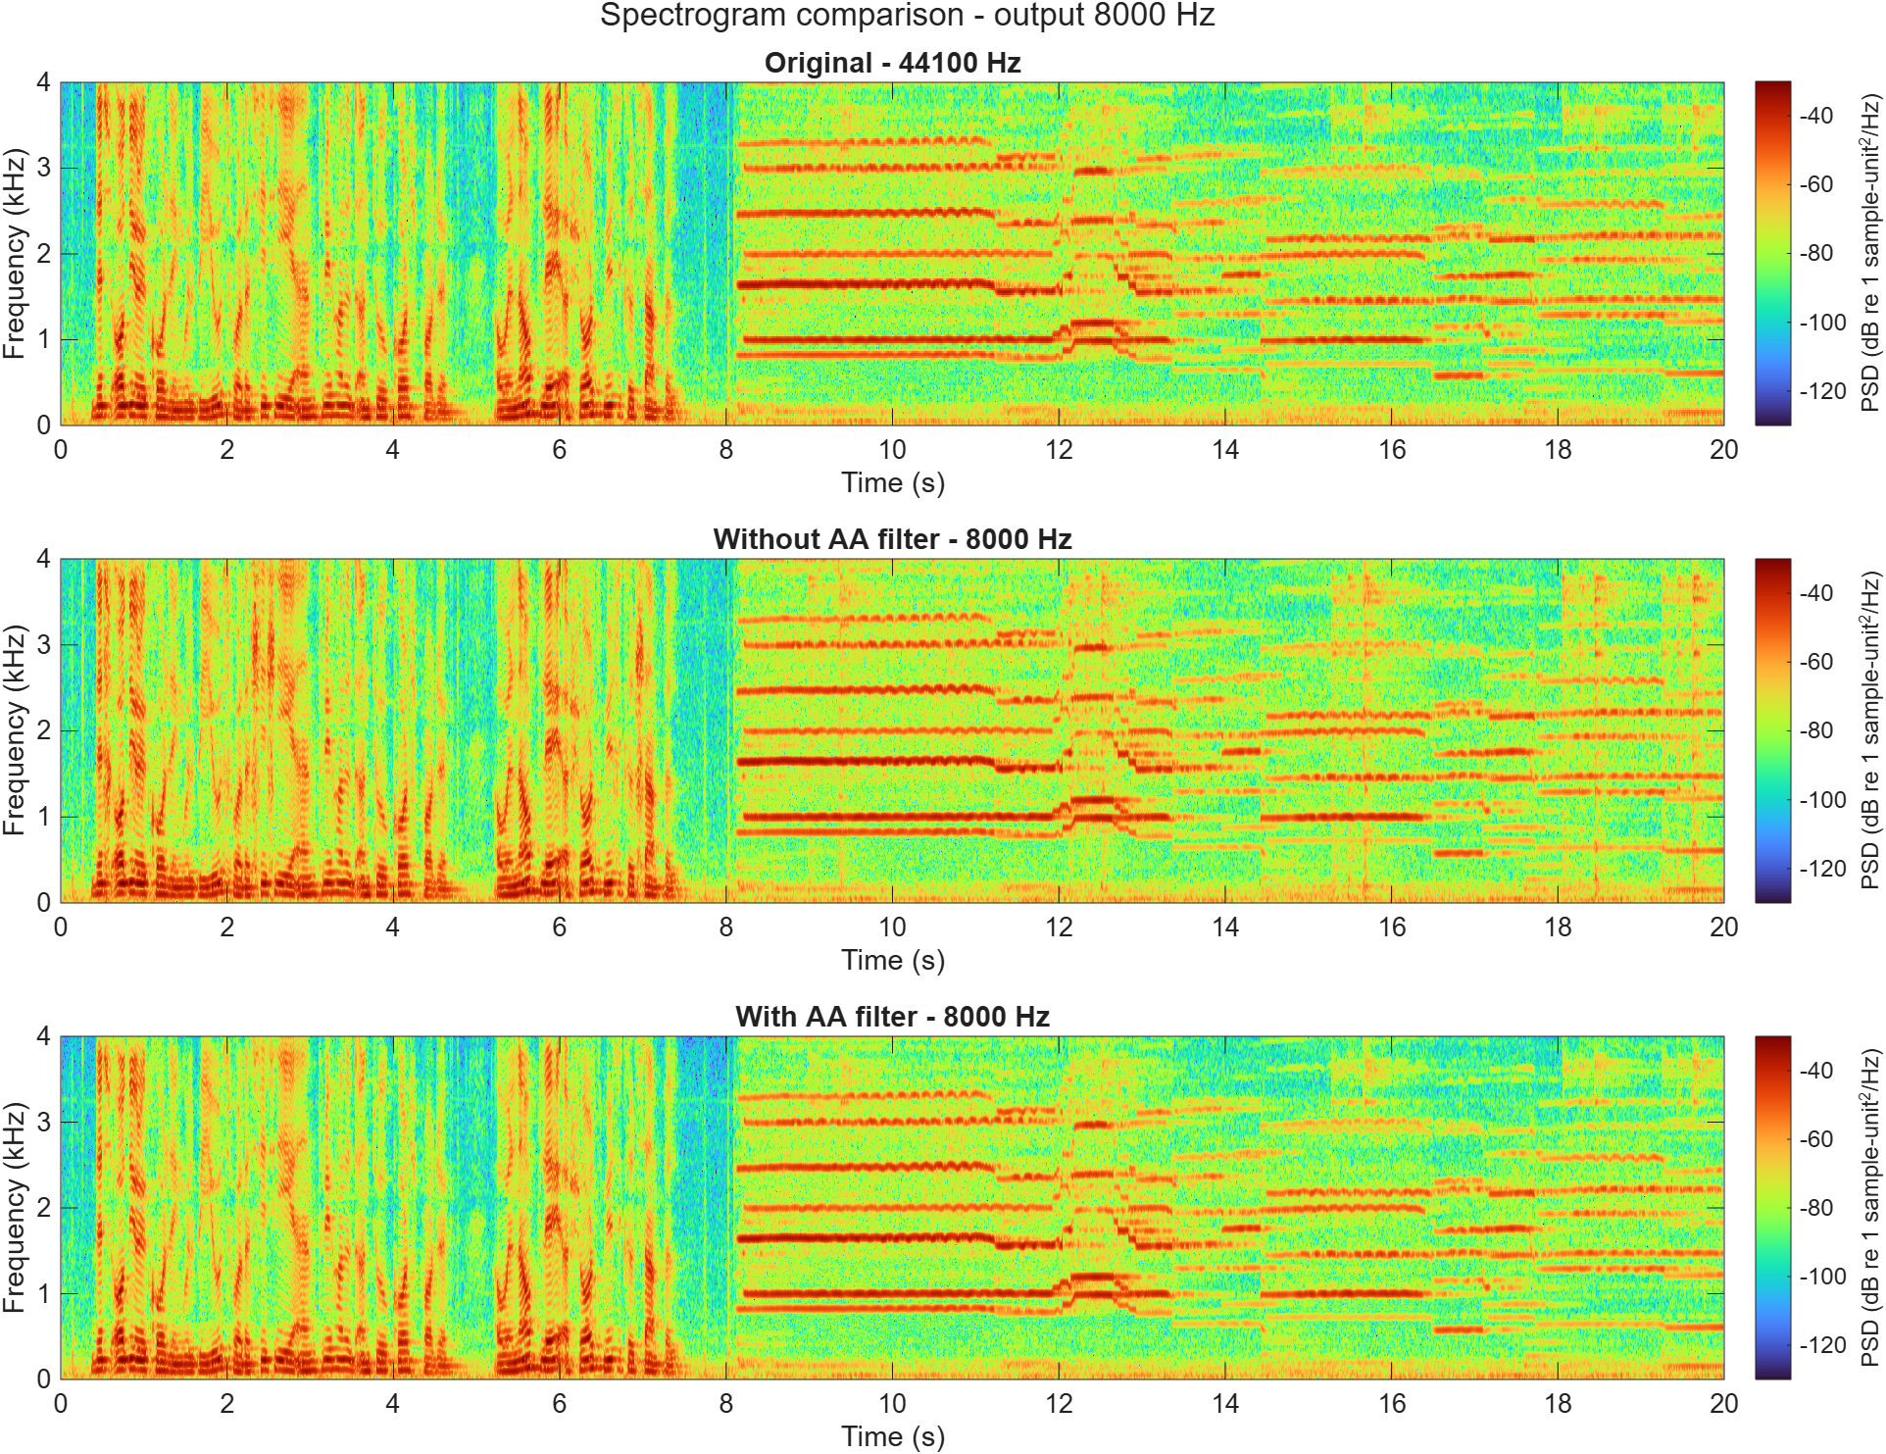
Figure A8000-2. Original, unfiltered and filtered PSD on the shared 0-4 kHz band, with the settings stated in Section 2.1.
These supporting plots complete the time-domain and time-frequency evidence across all four requested output rates. Full-resolution FFT plots, including shared-band dB views, remain in the reproducible results folder.

